SOFTWARE

REQUIREMENTS SPECIFICATION

For

STOCK PORTFOLIO TRACKER

DONE BY

- SENTHAMIL ARASU T
- SUBBURAJ V
- VIGNESH V

1. Introduction
1.1 Purpose
A portfolio is defined as a collection of investment assets. Portfolio management refers to the process of investment decision making based on customized tactical investment strategies to match maximize the return for each investing time horizon. There are two popular approaches to manage the investment portfolio: traditional and quantitative. Both approaches share some common characteristics such as investigating a small set of key-driving factors of equity values, analyzing historical data to estimate these key drivers, adopting eligibility criteria for stock-selection decisions, and evaluating the performance over time. However, while traditional portfolio management relies heavily on the judgment depth analysis, regime shifts, key characteristics, and qualitative factors, quantitative portfolio management focuses on universe exploration, discipline, verification, risk management, and lower fees. Not only can it uncover mode opportunities, but it can also do a better job of controlling unintended risks [1].

1.2 Document Conventions
- Entire document should be justified.

- Convention for Main title

- Convention for Sub title

- Convention for body
Font face: Times New Roman

Font Size: 12

1.3 Scope of Development Project

Portfolio Management: Users can input their stock holdings and track the performance of their investments in real-time. It helps in monitoring the overall health of the portfolio.

Performance Analysis: Tools for analyzing the performance of individual stocks, sectors, or the entire portfolio over specific periods. They often include charts, graphs, and analytics to visualize performance metrics.

Real-Time Updates: Providing real-time updates on stock prices, market news, and relevant financial information that might impact investment decisions.

Alerts and Notifications: Alerting users about significant market movements, price changes of specific stocks, or meeting certain investment criteria set by the user.

Diversification Analysis: Assessing the diversification of the portfolio across different asset classes, sectors, industries, or geographic regions.

Risk Management: Tools to evaluate and manage the risk associated with investments by assessing volatility, beta, and other risk measures.

Tax and Reporting: Some portfolio trackers offer features to assist in tax reporting by providing data on capital gains, dividends, and other relevant tax information.

1.4 Definitions, Acronyms and Abbreviations

JAVA -> platform independence

SQL-> Structured query Language
ER-> Entity Relationship
UML -> Unified Modeling Language
IDE-> Integrated Development Environment
SRS-> Software Requirement Specific

2.1 Product Perspective
Use Case Diagram of Library Management System

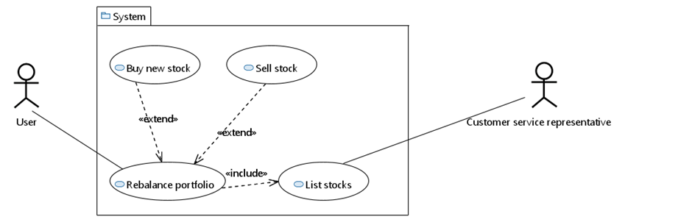
system.The users of the system can request issue/renew/return of books for which they would have to follow certain criteria.

2.2 Product Function

- The Online Library System provides online real time information about the books available in the Library and the user information. The main purpose of this project is to reduce the manual work.

- This software is capable of managing Book Issues, Returns, Calculating/Managing Fine, Generating various Reports for Record-Keeping according to end user requirements. The Librarian will act as the administrator to control members and manage books.

- The member’s status of issue/return is maintained in the library database. The member’s details can be fetched by the librarian from the database as and when required.

- The valid members are also allowed to view their account information.

User Entity (Users):

This entity represents individuals using the portfolio tracker.

It may contain attributes like UserID (unique identifier), Username, Password, Email, etc.

Portfolio Entity (Portfolios):

This entity represents the portfolios created by users. Attributes may include PortfolioID (unique identifier), PortfolioName, Description, CreationDate, etc. One user can have multiple portfolios (one-to-many relationship: User -> Portfolios).

Stock Entity (Stocks):

This entity contains information about the stocks available in the system. Attributes might include StockID (unique identifier), StockSymbol, CompanyName, Sector, CurrentPrice, etc.
Entity Relationship Diagram of stock portfolio tracker

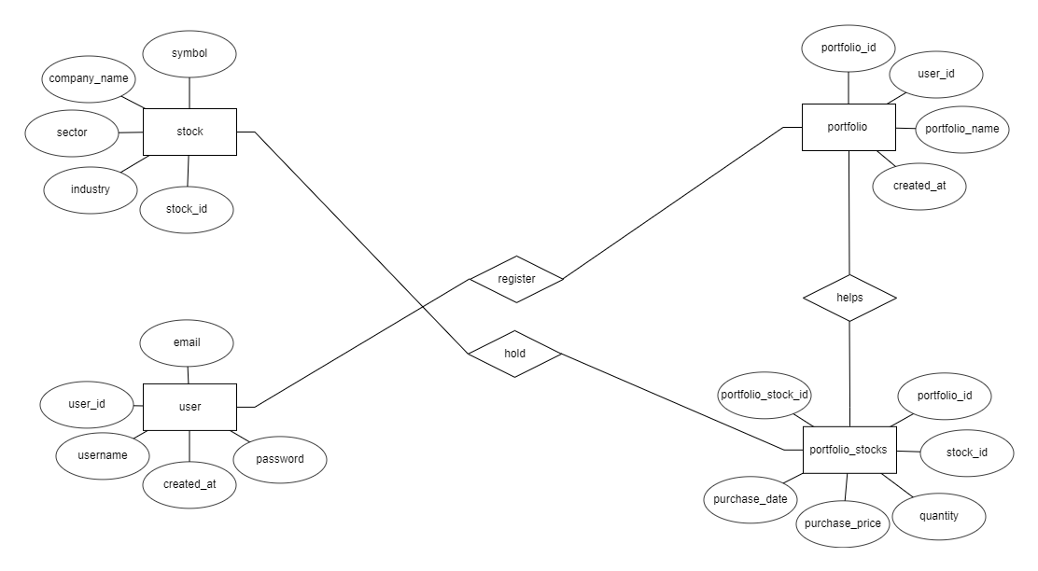
2.3 User Classes and Characteristics
Novice Investors:

Characteristics:
Limited knowledge about the stock market and investing.
Prefer easy-to-use interfaces and guidance.
Interested in learning and educational resources.
Needs:
Basic portfolio tracking and visualization tools.
Educational content about investing.
Simulated portfolios for practice.
Experienced Investors:

Characteristics:
Moderate to advanced knowledge of investing and financial markets.Looking for in-depth analysis tools and customization options.Prefer data-driven decision-making.

Needs:
Advanced analytics and performance measurement tools.
Customizable dashboards and reports.
Tools for technical and fundamental analysis.
Active Traders:

Characteristics:
Engage in frequent buying and selling of stocks.
Require real-time market data and alerts.
High focus on short-term gains.

Needs:
Real-time stock prices and market news.
Advanced charting tools for technical analysis.
Customizable alerts for price changes or specific criteria.
Long-Term Investors:

Characteristics:

Patient investors focused on long-term growth.

Diversified portfolios with a focus on stability and steady growth.

Interested in dividend reinvestment and retirement planning.

Needs:
Tools for portfolio diversification analysis.

Dividend tracking and reinvestment options.

Retirement planning calculators and projections.

Financial Advisors/Professionals:

Characteristics:

Manage multiple clients' portfolios.

Require comprehensive analytics and reporting tools.

Focus on risk management and compliance.

Needs:

Multi-account management capabilities. Customizable reporting and client communication toolsCompliance and regulatory adherence features.

2.4 Operating Environment

The portfolio tracker should ideally be accessible across various devices and operating systems (Windows, macOS, iOS, Android) through web browsers or dedicated mobile applications.Integration with reliable financial data sources to fetch real-time stock prices, market news, and financial information.Robust security protocols to protect user data, employing encryption, secure login methods, and regular updates to safeguard against cybersecurity threats.The system should handle a growing number of users and data inputs without compromising speed or performance. Dependence on a stable internet connection for real-time data updates and smooth functionality.Compliance with financial regulations and data protection laws (such as GDPR, CCPA, etc.) governing financial services and personal data handling.Regular backup procedures to prevent data loss in case of system failures or unforeseen events.

2.5 Assumptions and Dependencies

The assumptions are:-
- The coding should be error free

- The system should be user-friendly so that it is easy to use for the users

- The information of all users, books and libraries must be stored in a database that is accessible by the website

- The system should have more storage capacity and provide fast access to the database

- The system should provide search facility and support quick transactions

- The Library System is running 24 hours a day

- Users may access from any computer that has Internet browsing capabilities and an

Internet connection

- Users must have their correct usernames and passwords to enter into their online accounts and do actions

The dependencies are:-
- The specific hardware and software due to which the product will be run

- On the basis of listing requirements and specification the project will be developed and run

- The end users (admin) should have proper understanding of the product

- The system should have the general report stored

- The information of all the users must be stored in a database that is accessible by the Library System

- Any update regarding the book from the library is to be recorded to the database and the data entered should be correct

2.6 Requirement

Software Configuration:-

This software package is developed using java as front end which is supported by sun micro system. Microsoft SQL Server as the back end to store the database. Operating System: Windows NT, windows 98, Windows XP

Language: Java Runtime Environment, Net beans 7.0.1 (front end)
Database: MS SQL Server (back end)

Hardware Configuration:-
Processor: Pentium(R)Dual-core CPU
Hard Disk: 40GB
RAM: 256 MB or more

2.7 Data Requirement

Stock Market Data:

- Real-Time Stock Prices:
- Continuous updates on stock prices for various exchanges and markets.
- Historical Price Data: Past stock prices for analysis and performance tracking.
- Market Indices: Information on major market indices (e.g., S&P 500, NASDAQ) for benchmarking and comparison.
- Volume and Market Cap: Trading volume and market capitalization data for each stock.
- Dividend Information: Details on dividend payouts for dividend-paying stocks.
- Company Information:

- Company Profiles: Information about companies listed on the stock exchange, including industry, sector, CEO, headquarters location, etc.
- Financial Statements: Access to company financials (income statements, balance sheets, cash flow statements) for fundamental analysis.
- Earnings Reports: Quarterly and annual earnings reports, including revenue, earnings per share (EPS), and forecasts.
- Corporate Actions: Details on mergers, acquisitions, stock splits, dividends, and other corporate events impacting stock prices.
- User Portfolio Data:

- Portfolio Holdings: Information on stocks held by users, including quantities, purchase prices, and current valuations.
- Transaction History: Records of buy and sell transactions, including dates, quantities, prices, and total amounts.
- Performance Metrics: Calculations for portfolio performance, including overall returns, gains/losses, and percentage changes.
- Market News and Analysis:

- Financial News Feeds: Timely news articles, market updates, and analyst reports affecting stock prices.
- Expert Analysis: Insights and commentary from financial experts and analysts.
- Market Trends: Information on market trends, sentiment analysis, and macroeconomic indicators.
- Risk and Analytics Data:

- Volatility Measures: Volatility indices or measures like beta, standard deviation, etc., to assess stock risk.
- Portfolio Diversification Analysis: Tools to evaluate portfolio diversification across sectors, industries, asset classes, etc.
- Risk-Adjusted Returns: Calculations for risk-adjusted returns (e.g., Sharpe ratio) to assess investment performance considering risk..

3. External Interface Requirement
3.1 GUI
- Dashboard Overview:

- Welcome screen displaying a summary of the user's portfolios, overall portfolio value, recent activity, and market indices.
- At-a-glance visualization of portfolio performance through charts (line graphs, pie charts, etc.) showing asset allocation, gains/losses, and distribution by sector or asset class.
- Portfolio Management:

- Interface for adding, editing, and managing multiple portfolios.
- Ability to view individual portfolios with detailed breakdowns of holdings, including stock symbols, quantities, current values, and total portfolio value.
- Quick access to transaction history and performance metrics for each portfolio.
- Stock Research and Analysis:

- Search functionality to look up stocks by symbol, company name, or sector.
- Detailed stock profiles displaying key metrics (current price, market cap, P/E ratio, dividend yield, etc.), company information, financial statements, and analyst ratings.
- Charting tools for visualizing historical stock prices, technical indicators, and comparing multiple stocks' performance.
- Transaction Handling:

- Interface for buying/selling stocks within portfolios with options to set trade parameters (quantity, price, order type).
- Transaction history log with details of executed trades, including date, stock symbol, quantity, price, and total amount.
- Market Data and News:

- Real-time stock prices, market indices, and updates on major market movements.
- Integration with financial news feeds and expert analysis for informed decision-making.
- Alerts or notifications for significant price changes or market events.
- Analytics and Performance Metrics:

- Tools for analyzing portfolio performance, including overall returns, gains/losses, and performance against benchmarks.
- Risk assessment metrics (beta, standard deviation, Sharpe ratio) for evaluating portfolio risk-adjusted returns.
- Diversification analysis to assess portfolio balance across sectors, industries, or asset classes.
- Customization and Settings:

- User preferences for customizing dashboard layout, themes, and display options.
- Alert settings for personalized notifications on specific stock movements or portfolio changes.
- Account management functionalities, including profile settings, security options, and data privacy settings.
- Help and Support:

- Access to FAQs, tutorials, or help guides to assist users in navigating the platform and understanding features.
- Customer support contact information for assistance with technical issues or inquiries.aa

4. System Features

The users of the system should be provided the surety that their account is secure. This is possible by providing:-
  - User authentication and validation of members using their unique member ID

  - Proper monitoring by the administrator which includes updating account status, showing a popup if the member attempts to issue number of books that exceed the limit provided by the library policy, assigning fine to members who skip the date of return

  - Proper accountability which includes not allowing a member to see other member’s account. Only administrator will see and manage all member accounts

- Other Non-functional Requirements

5.1 Performance Requirement

The proposed system that we are going to develop will be used as the Chief performance system within the different campuses of the university which interacts with the university staff and students. Therefore, it is expected that the database would perform functionally all the requirements that are specified by the university.
- The performance of the system should be fast and accurate

- Library Management System shall handle expected and non-expected errors in ways that prevent loss in information and long downtime period. Thus it should have inbuilt error testing to identify invalid username/password

- The system should be able to handle large amount of data. Thus it should accommodate high number of books and users without any fault

5.2 Safety Requirement
The database may get crashed at any certain time due to virus or operating system failure. Therefore, it is required to take the database backup so that the database is not lost. Proper UPS/inverter facility should be there in case of power supply failure.

5.3 Security Requirement
- System will use secured database

- Normal users can just read information but they cannot edit or modify anything except their personal and some other information.

- System will have different types of users and every user has access constraints

- Proper user authentication should be provided

- No one should be able to hack users’ password

- There should be separate accounts for admin and members such that no member can access the database and only admin has the rights to update the database.

5.4 Requirement attributes

- There may be multiple admins creating the project, all of them will have the right to create changes to the system. But the members or other users cannot do changes
- The project should be open source

- The Quality of the database is maintained in such a way so that it can be very user friendly to all the users of the database

- The user be able to easily download and install the system

5.5 Business Rules

A business rule is anything that captures and implements business policies and practices. A rule can enforce business policy, make a decision, or infer new data from existing data.This includes the rules and regulations that the System users should abide by. This includes the cost of the project and the discount offers provided. The users should avoid illegal rules and protocols. Neither admin nor member should cross the rules and regulations.

5.6 User Requirement

The users of the system are members and Librarian of the university who act as administrator to maintain the system. The members are assumed to have basic knowledge of the computers and internet browsing. The administrators of the system should have more knowledge of the internals of the system and is able to rectify the small problems that may arise due to disk crashes, power failures and other catastrophes to maintain the system. The proper user interface, user manual, online help and the guide to install and maintain the system must be sufficient to educate the users on how to use the system without any problems.

The admin provides certain facilities to the users in the form of:-
- Backup and Recovery

- Forgot Password

- Data migration i.e. whenever user registers for the first time then the data is stored in the server

- Data replication i.e. if the data is lost in one branch, it is still stored with the server

- Auto Recovery i.e. frequently auto saving the information

- Maintaining files i.e. File Organization

- The server must be maintained regularly and it has to be updated from time to time

6. Other Requirements
6.1 Data and Category Requirement

There are different categories of users namely teaching staff, Librarian, Admin, students etc. Depending upon the category of user the access rights are decided.It means if the user is an administrator then he can be able to modify the data,delete, append etc. All other users except the Librarian only have the rights to retrieve the information about database. Similarly there will be different categories of books available. According to the categories of books their relevant data should be displayed. The categories and the data related to each category should be coded in the particular format.

6.2 Appendix

- Admin, Abbreviation, Acronym, Assumptions; B: Books, Business rules; C: Class, Client, Conventions; D: Data requirement, Dependencies; G: GUI; K: Key; L: Library, Librarian; M:

Member;N:Non-functionalRequirement;O:Operatingenvironment;P:
Performance,Perspective,Purpose; R: Requirement, Requirement attributes; S: Safety, Scope,
Security, System features; U: User, User class and characteristics, User requirement;

6.3 Glossary

The following are the list of conventions and acronyms used in this document and the project as well:

- Administrator: A login id representing a user with user administration privileges to the software

- User: A general login id assigned to most users

- Client: Intended users for the software
➢ SQL: Structured Query Language; used to retrieve information from a database
- SQL Server: A server used to store data in an organized format

- Layer: Represents a section of the project

- User Interface Layer: The section of the assignment referring to what the user interacts with directly

- Application Logic Layer: The section of the assignment referring to the Web Server. This is where all computations are completed
- Data Storage Layer: The section of the assignment referring to where all data is recorded

- Use Case: A broad level diagram of the project showing a basic overview

- Class diagram: It is a type of static structure diagram that describes the structure of a system by showing the system’s cases, their attributes, and the relationships between the classes
- Interface: Something used to communicate across different mediums

- Unique Key: Used to differentiate entries in a database

6.4 Class Diagram

A class is an abstract, user-defined description of a type of data. It identifies the attributes of the data and the operations that can be performed on instances (i.e. objects) of the data. A class of data has a name, a set of attributes that describes its characteristics, and a set of operations that can be performed on the objects of that class. The classes’ structure and their relationships to each other frozen in time represent the static model. In this project there are certain main classes

which are related to other classes required for their working. There are different kinds of relationships between the classes as shown in the diagram like normal association, aggregation, and generalization. The relationships are depicted using a role name and multiplicities. Here ‘Librarian’, ‘Member’ and ‘Books’ are the most important classes which are related to other classes.

